24CSI024-DATA STRUCTURES AND ALGORITHMS UNIT 1-INTRODUCTION TO DATA STRUCTURES AND ALGORITHMS
Arrays and Array-Based Techniques (Two-Pointer, Sliding Window, Prefix Sums)
LAB WORKBOOK-16.07.2026

CATEGORY: EASY

Question 1: Merging Two Sensor Logs (Two-Pointer)
Two weather stations, A and B, each recorded temperature readings independently and stored them in non-decreasing sorted order. Divya needs to merge both logs into a single sorted array for her analysis dashboard — without using any built-in sort function, and in O(N + M) time.
She uses the two-pointer merge technique:
- Initialize a pointer i at index 0 of array A and a pointer j at index 0 of array B.
- Compare A[i] and B[j]. Copy the smaller value into the output array and advance that pointer.
- Repeat until one array is exhausted.
- Copy any remaining elements of the other array directly into the output.
10 | 2 2  0 0  -1 4
5 8 9 10 | -1 0 0 4
- The first line of input consists of two space-separated integers N and M — the sizes of arrays A and B.
- The second line consists of N space-separated integers (array A, sorted).
- The third line consists of M space-separated integers (array B, sorted).
- Print a single line of N + M space-separated integers representing the merged sorted array.
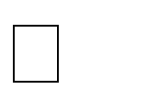

- 1  N, M  10000



-  10⁴  arr[i]  10⁴

Input 1: Input 2:

9
8
Output: Output:

3
Aim:
To merge the two given array and print the sorted merged array using two pointer technique.
Pseudocode
Algorithm: Merge Two Sorted Arrays

Step 1: Start.
Step 2: Read the values of n and m.
Step 3: Declare arrays A[n] and B[m].
Step 4: Read n elements into array A.
Step 5: Read m elements into array B.
Step 6: Declare array Result[n + m].
Step 7: Initialize i = 0, j = 0, and k = 0.
Step 8: Repeat while both arrays have elements:
a. If A[i] is smaller than B[j]:
Store A[i] in Result[k].
Increment i and k.
b. Otherwise:
Store B[j] in Result[k].
Increment j and k.
Step 9: Display all elements of the Result array.
Step 10: Stop.

C program

#include <stdio.h>

int main() {
int n,m;
scanf("%d%d",&n,&m);
int arr[n],arr2[m];
for (int i=0;i<n;i++){
scanf("%d",&arr[i]);
}
for (int i=0;i<m;i++){
scanf("%d",&arr2[i]);
}
int result[n+m];
int i=0;
int j=0;
int k=0;
while(i+j<=n+m){
if (arr[i]<arr2[j]){
result[k]=arr[i];
k++;
i++;
}
else{
result[k]=arr2[j];
j++;
k++;

}
}
for (int i=0;i<n+m;i++){
printf("%d ",result[i]);
}

return 0;
}

Screenshot of the output
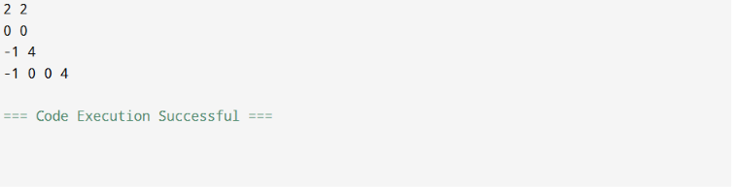

Result:
Thus, the program successfully merged two sorted arrays into a sorted result array using the Two Pointer Technique.

Question 2: Locating the First Below-Threshold Reading (Linear Search)
Farhan monitors battery voltage readings from a fleet of IoT sensors, logged in
the order they were received (not sorted). He needs to find the position of the first reading that drops below a safe voltage threshold T, so maintenance can pinpoint when the fault began.
- The first line of input consists of two space-separated integers N and T.
- The second line consists of N space-separated integers representing the voltage readings, in the order recorded.

- Print a single integer: the 0-indexed position of the first reading strictly less than T. If no such reading exists, print -1.


- 1  N  10000



-  10³  arr[i], T  10³

Input 1: Input 2:

6 5  9 7 6 4 8 3 | 4 0  1 2 3 4
Output: |  | Output:
3 | -1

Aim
To write a C program to find the index of the first element that is less than a given threshold using the Linear Search technique.
Pseudocode
- Start.
- Read the values of N and T.
- Declare an array vol[N].
- Read the array elements.
- Initialize count = 0.
- Traverse the array from index 0 to N-1.
- If vol[i] < T:
  - Print i.
  - Increment count.
  - Exit the loop.
- If count == 0, print -1.
- Stop.
C Program
#include <stdio.h>
int main(){
int n,t;
scanf("%d%d",&n,&t);
int vol[n];
for (int i=0;i<n;i++){
scanf("%d",&vol[i]);
}
int count=0;
for (int i=0;i<n;i++){
if (vol[i]<t){
printf("%d",i);
count++;
break;
}
}
if (count==0){
printf("-1");
}
}
Screenshot of the output
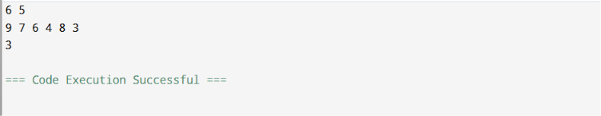
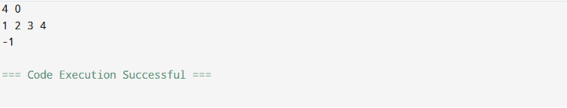
Result
Thus, the program was successfully executed to find the index of the first element that is less than the given threshold using the Linear Search technique.

CATEGORY: MEDIUM

Question 3: Maximum Rainwater Between Towers (Two-Pointer)
A telecom company has N transmission towers of varying heights standing in a row. During heavy rain, water can collect in the “well” formed between two towers, bounded by the shorter of the two. Meera wants to find the two towers that can trap the maximum volume of water between them, so she can plan drainage.
She solves it in O(N) using two pointers instead of checking every pair:
- Initialize left = 0 and right = N - 1, and maxWater = 0.
- Compute the water trapped between left and right: min(height[left], height[right]) * (right - left). Update maxWater if this is larger.
- Move the pointer at the shorter tower inward — it can never form a better pair with anything closer than the taller side already offers.
- Repeat until left meets right.
  - The first line of input consists of an integer N — the number of towers.
  - The second line consists of N space-separated non-negative integers representing tower heights.
  - Print a single integer representing the maximum water that can be trapped, in the format: Max Water: X.


  - 2  N  10000


  - 0  height[i]  10⁴

Input 1: Input 2:

6
Output: Output:

Max Water: 49 | Max Water: 3

2 5 4 8 3 7 | 4  1 1 1 1
Aim
To write a C program to find the maximum amount of water that can be trapped between two towers using the Two-Pointer Technique
1. Start.
2. Read the value of n.
3. Declare an array height[n].
4. Read the elements of the array.
5. Initialize:
i = 0
j = N - 1
maxx = 0
6. Repeat while i < j:
a. Find the smaller of height[i] and height[j].
b. Calculate:
water = smaller height × (j - i)
c. If water > maxx,
maxx= water
d. If height[i] < height[j],
Increment i
Else
Decrement j
7. Print "Max Water: " followed by maxx.

8. Stop.

C Program
#include <stdio.h>

int main() {
int n;
scanf("%d", &n);

int height[n];

for (int i = 0; i < n; i++) {
scanf("%d", &height[i]);
}

int i = 0;
int j = n - 1;
int maxx = 0;

while (i < j) {
int h;

if (height[i] < height[j])
h = height[i];
else
h = height[j];

int water = h * (j - i);

if (water > maxx)
maxx = water;

if (height[i] < height[j])
i++;
else
j--;
}

printf("Max Water: %d", maxx);

return 0;
}
Screenshot of the output
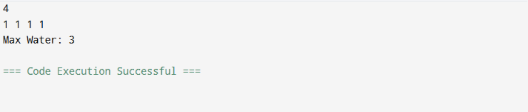
Result
Thus, the program was successfully executed to find the maximum amount of water that can be trapped between two towers using the Two-Pointer Technique.

Question 4: Finding the Insertion Point for a New Calibration Value (Binary Search)
A lab keeps a sorted array of calibration reference values. Whenever a new value arrives, Ibrahim needs to find the exact index where it should be inserted to keep the array sorted — without scanning the whole array.
He uses a binary search variant that finds the first index whose value is greater than or equal to the new value:
- Initialize low = 0, high = N.
- While low < high: compute mid = low + (high - low) / 2.
- If arr[mid] < target, set low = mid + 1. Otherwise, set high = mid.
- When the loop ends, low is the correct insertion index.
- The first line of input consists of two space-separated integers N and target.
- The second line consists of N space-separated integers in non-decreasing order.
- Print a single integer: the index at which target should be inserted, in the format: Insert At: X.


- 1  N  10000



-  10⁴  arr[i], target  10⁴

Input 1: Input 2:

6 29 | 4 5  1 2 3 4
10 20 30 40 50 60
Output: Output:

Insert At: 2 | Insert At: 4

Aim
To write a C program to find the correct insertion index of a target element in a sorted array using the Binary Search technique.

Pseudocode

1. Start.
2. Read the values of N and target.
3. Declare an array arr[N].
4. Read the elements of the array.
5. Initialize:
i = 0
j = N
6. Repeat while i < j:
a. Find mid = i + (j - i) / 2.
b. If arr[mid] < target,
i = mid + 1
Else
j = mid
7. Print "Insert At: " followed by low.
8. Stop.

C Program
#include <stdio.h>

int main() {
int n, target;
scanf("%d%d", &n, &target);

int arr[n];

for (int i = 0; i < n; i++) {
scanf("%d", &arr[i]);
}

int i = 0;
int j = n;

while (i < j) {
int mid = i + (j - i) / 2;

if (arr[mid] < target)
i = mid + 1;
else
j = mid;
}

printf("Insert At: %d", i);

return 0;
}
Screenshot of the output
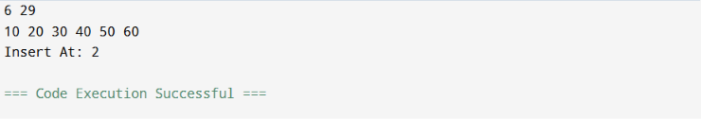
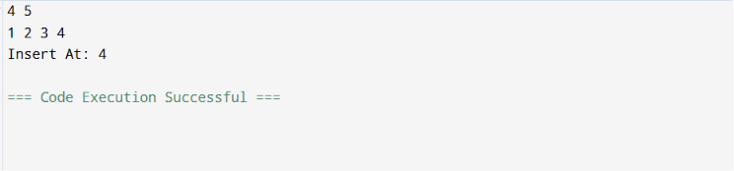
Result
Thus, the program was successfully executed to find the correct insertion index of the target element in a sorted array using the Binary Search technique.

CATEGORY: HARD

Question 5: Locating a Packet in a Rotated Log Buffer (Modified Binary Search)
A circular network buffer stores log entries sorted by timestamp, but because it wraps around, the array as read out is a rotated sorted array (e.g., the oldest entries appear after the newest due to the wraparound point). Sana needs to locate a specific timestamp T in O(log N) time — a plain binary search won’t work directly since the array isn’t fully sorted end-to-end.
She adapts binary search to handle the rotation:
- Initialize low = 0, high = N - 1.
- Compute mid. If arr[mid] == target, return mid.
- Determine which half (low to mid, or mid to high) is properly sorted by comparing arr[low] and arr[mid].
- Check if target lies within the value range of the sorted half. If it does, recurse/iterate into that half; otherwise, search the other half.
- Repeat until found or the range is empty.
- The first line of input consists of two space-separated integers N and target.

- The second line consists of N space-separated distinct integers representing the rotated sorted array.
- Print a single integer: the 0-indexed position of target in the array, in the format: Found At: X. If not present, print Found At: -1.


- 1  N  10000



-  10⁵  arr[i], target  10⁵
- The array is a sorted array rotated at some unknown pivot; all elements are distinct.

Input 1: Input 2:

7 0  4 5 6 7 0 1 2 | 5 3  4 5 6 7 8
Output: | Output:
Found At: 4 | Found At: -1

Aim
To write a C program to find the position of a target element in a rotated sorted array using the Modified Binary Search technique.

Pseudocode
1. Start.
2. Read the values of N and target.
3. Declare an array arr[N].
4. Read the elements of the array.
5. Initialize:
low = 0
high = N - 1
6. Repeat while low <= high:
a. Find mid = low + (high - low) / 2.
b. If arr[mid] == target,
Print "Found At: " followed by mid.
Stop.
c. If the left half is sorted:
If target lies in the left half,
high = mid - 1
Else
low = mid + 1
d. Otherwise, the right half is sorted:
If target lies in the right half,
low = mid + 1
Else
high = mid - 1
7. If the target is not found,
Print "Found At: -1".
8. Stop.
C Program
#include <stdio.h>

int main() {
int n, target;
scanf("%d%d", &n, &target);

int arr[n];

for (int i = 0; i < n; i++) {
scanf("%d", &arr[i]);
}

int i = 0;
int j = n - 1;

while (i <= j) {
int mid = i + (j - i) / 2;

if (arr[mid] == target) {
printf("Found At: %d", mid);
return 0;
}

if (arr[i] <= arr[mid]) {
if (target >= arr[i] && target < arr[mid])
j = mid - 1;
else
i = mid + 1;
} else {
if (target > arr[mid] && target <= arr[j])
i = mid + 1;
else
j = mid - 1;
}
}

printf("Found At: -1");

return 0;
}
Screenshot of the output
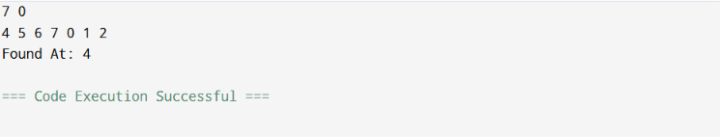
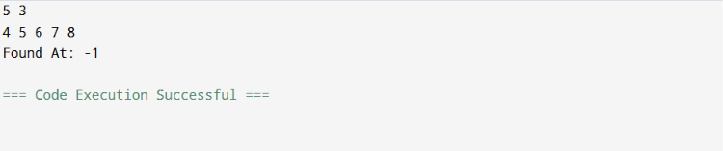
Result
Thus, the program was successfully executed to find the position of the target element in a rotated sorted array using the Modified Binary Search technique.

VIVA QUESTIONS:
- “In binary search, why must the array be sorted before we can safely discard half the search space at each step? What breaks if it isn’t?”
- “Contrast the worst-case and best-case time complexity of linear search. Under what real-world circumstance would linear search actually outperform binary search on the same data?”
- “In the rotated sorted array search problem, why can’t we simply check if arr[mid] < target the way we would in a standard binary search? What extra information do we need at each step?”
- “The two-pointer merge technique for two sorted arrays runs in O(N+M) time. Why would sorting the concatenation of both arrays from scratch be a worse approach, even though both are technically valid?”
- “In the ‘maximum rainwater between towers’ problem, why is it always safe to move the pointer at the shorter tower inward, and never the taller one?”
- “low + (high - low) / 2 is preferred over (low + high) / 2 for computing the midpoint in binary search. What specific failure does this guard against, and under what conditions would that failure actually occur in C?”
- “If you were asked to implement binary search recursively instead of iteratively in C, what trade-off would you be making in terms of memory, and why does this matter for embedded systems with limited stack size?”
- “How would you modify binary search to find the last occurrence of a repeated value in a sorted array, rather than just any occurrence?”
- “Explain why the two-pointer technique for merging arrays cannot be applied directly if one of the arrays is unsorted. What would need to change?”
- “In terms of cache behavior, why might linear search on a small array sometimes run faster in practice than binary search, despite having worse asymptotic complexity?”

